**Project Report**

**Piyush Jain**

**email id-:** [**piyushjain6369@gmail.com**](mailto:piyushjain6369@gmail.com)

**Python Project**

2018

**Sales and Inventory Management System**

**SCOPE**

The purpose of the whole project is to create a system for an organization that will manage their sales and inventory records. The scope of the project is to give a simple and attractive application to simplify the work of administrators and employees of the organization.

This project is affiliated to a bakery. It will maintain bakery’s sales and inventory’s record. It will enable bakery’s administrators and employees to maintain their record

more efficiently and easily.

**IMPLEMENTATION**

Project’s GUI is implemented using **Python** module Tkinter which has a **Database** at backend to maintain all records of the bakery. Project is implemented by using OOP Paradigm.

Database is implemented by a Python module Sqlite3.It is a SQl based database.

This project has two different account types, for bakery’s administrator and for bakery’s employee. Both accounts have different options according to their accessibility.

**RELATIONAL DATA BASE DESIGN**

* Login-: Login table is for keeping username, passwords and account type of users. Login table has three attributes -:
* Username (**Primary key**)
* Password (**Not Null**)
* Account type (**Not Null**)

Password and Account Type are mandatory fields.

* Products-: Product table is for keeping details of products in the bakery. Product table has 6 attributes-:
* Product id (**Primary key**)
* Product name (**Not Null**)
* Description
* Category
* Price (**Not Null**)
* Stock (**Not Null**)

Product Name, Price and Stock are mandatory fields.

* Sales-: Sales table is for keeping transaction records of the bakery. This table has 6 attributes-:
* Transaction id (**Primary key**)
* Invoice no. (**Not Null**)
* Product id (**Foreign key**)
* Quantity (**Not Null**)
* Date
* Time

Invoice no. and Quantity are mandatory fields.

Here Transaction no. is for transaction of product and Invoice no. is bill number.

These tables are in **3rd Normal form**.

**RUN PROGRAM**

To run Program, you have to run **main.py** on shell.

**LOGIN SCREEN**

From this screen you can login in as bakery’s administrator or bakery’s employee.

There are two different account types-:

* + Admin-: This account is for bakery’s administrators. Through this account you have rights to see every detail of the bakery. You can add or remove products, edit product details, check how sale is going in bakery, add or remove users, change their passwords and account types etc.
  + User-: This a Limited access account. This account is for employees of the bakery. Through this account you can sell products, make transaction, can see current products in bakery etc.

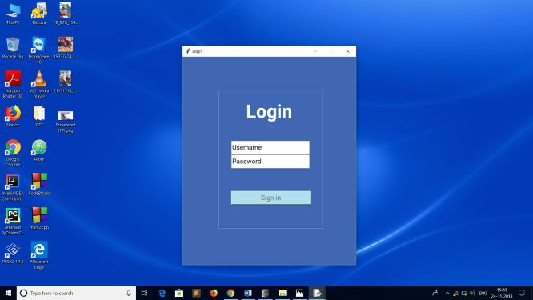

To login in Admin type account-:

Username-> PJ28105

Password-> ADMIN

To login in User type account-:

Username-> PJ

Password-> ADMIN

Username and Password are not case sensitive.

You can either click sign in button or press Enter to login.

**ADMIN ACCOUNT**

* Inventory-: An inventory window opens up. Through this window you can edit product details or add stock to the product or remove product that are out of stock. You can search in this table by product description.

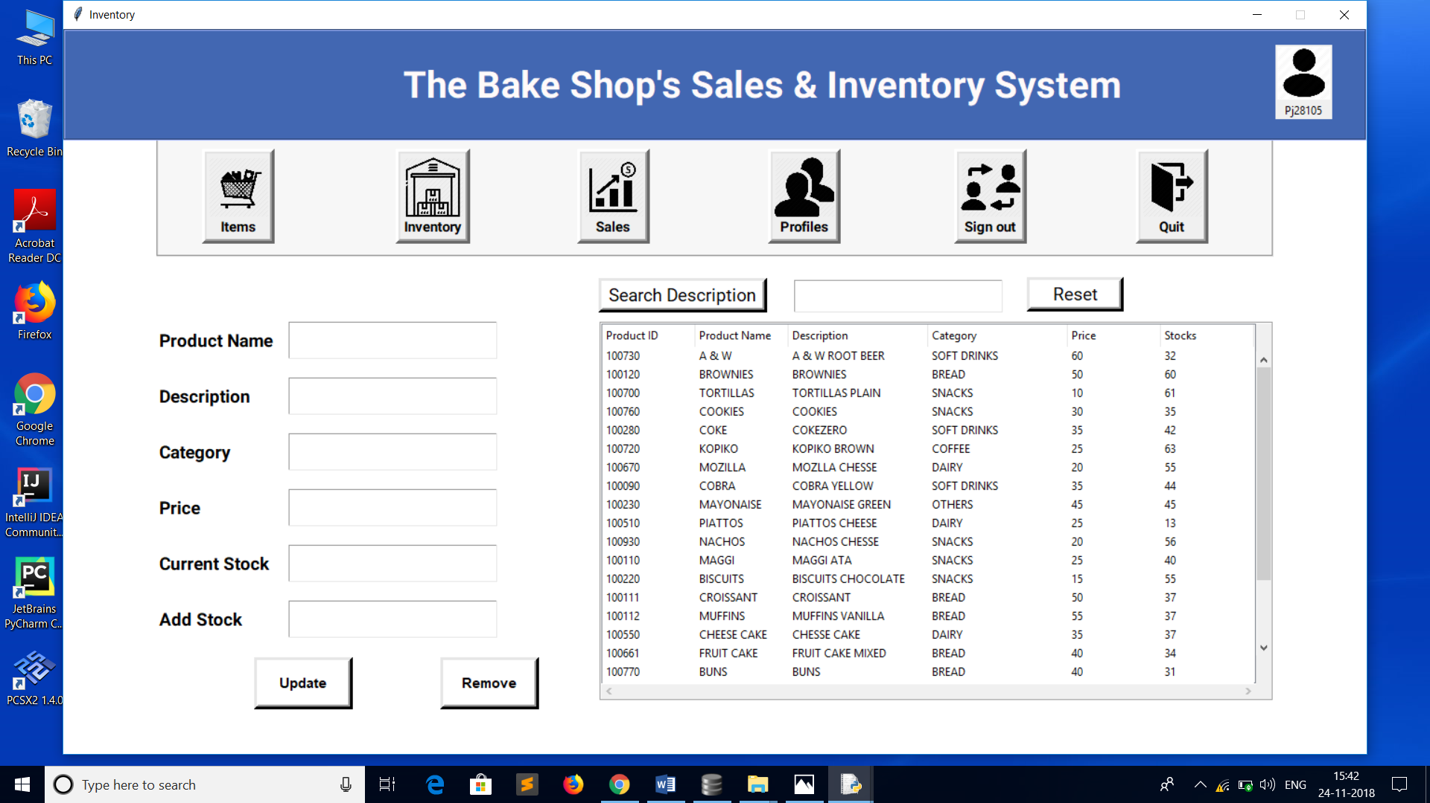

You can select any row of the table the entry boxed will fill automatically.

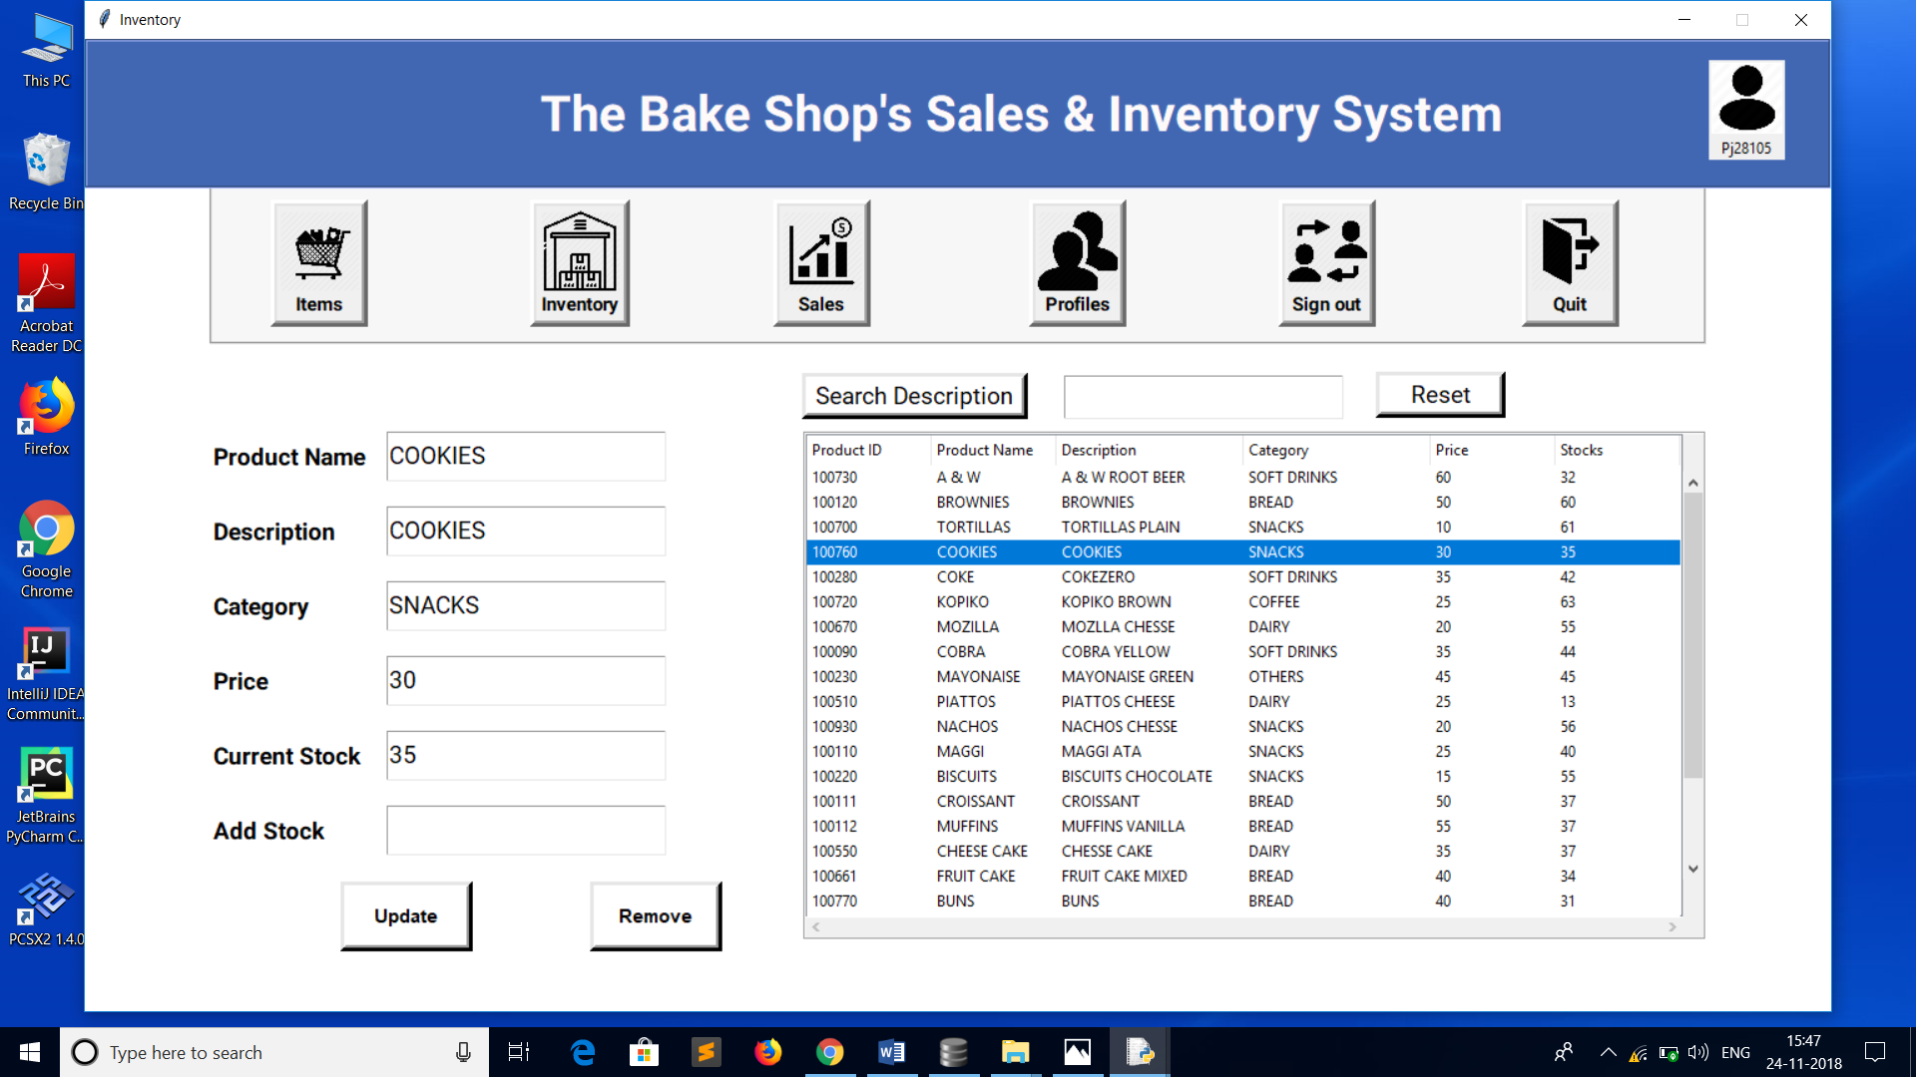

To update product detail just press update button. Table is dynamic in nature it will get automatically updated. To remove product just press remove button.

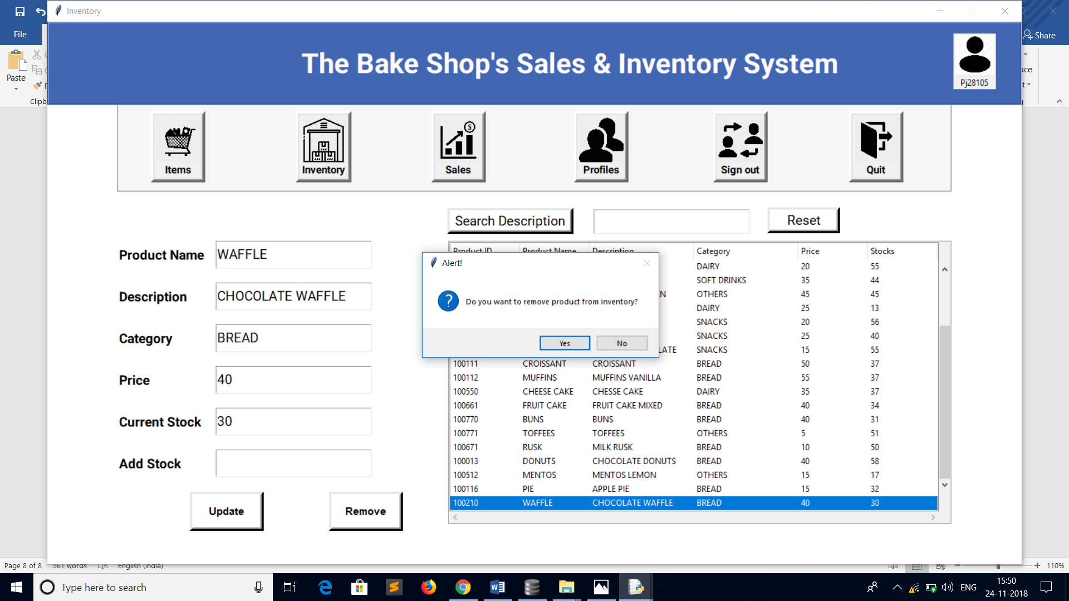

You can search Product by Description. Search Box is a suggestion box it will automatically provide suggestions to the user.

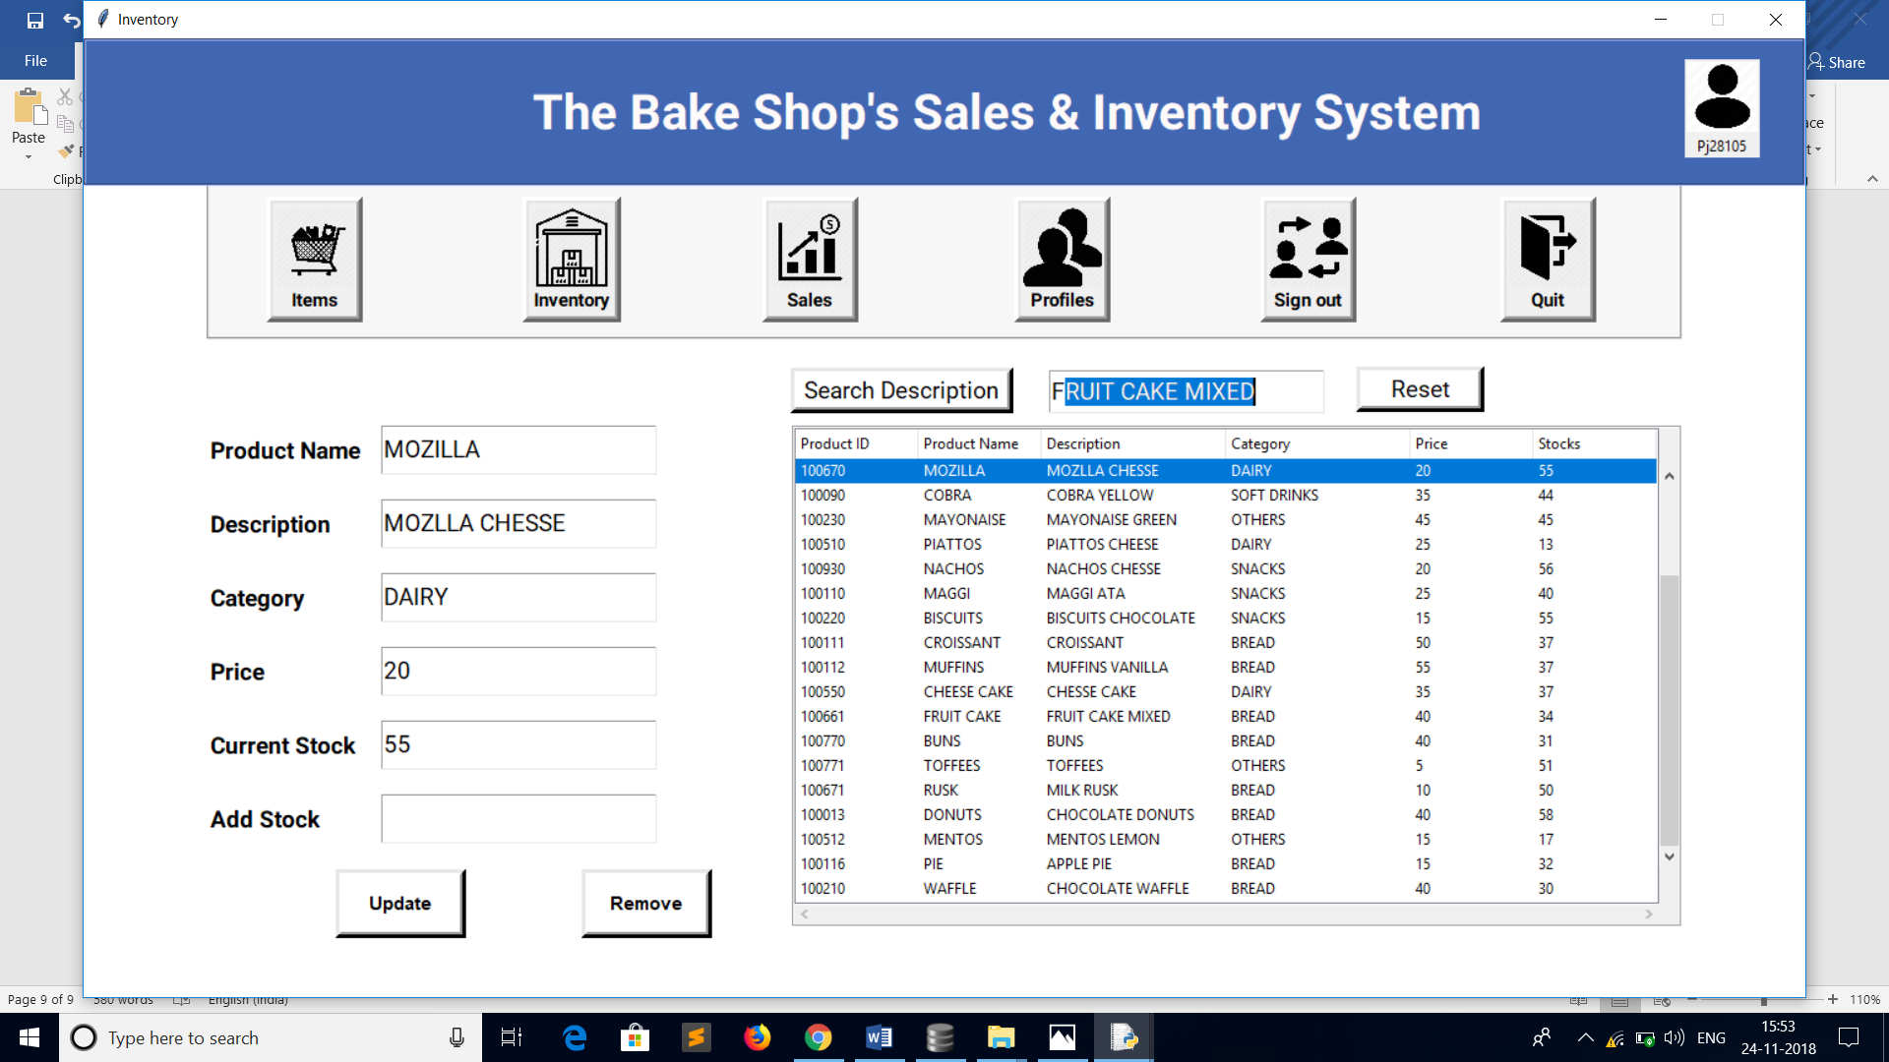

To reset search option just press reset button.

* Items-: You can add items to the inventory through items button. Here Product id should be in numbers. Product id and product description should be unique. Press **add item** button to add item to the bakery or **Back** button to go back to the inventory.

Here Category search box is a suggestion box it will fill automatically and will give suggestion to the user.

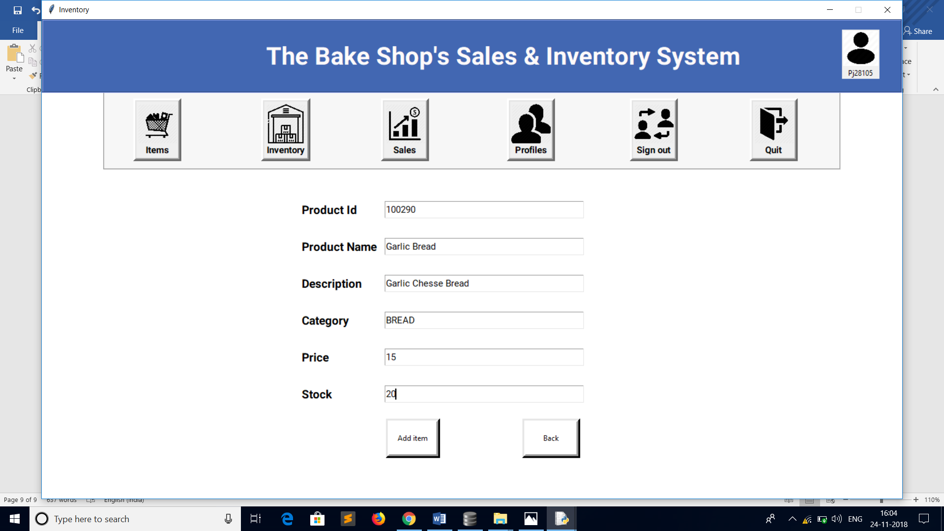

* Sales-: Through Sales button you can check the current sale progress in your bakery. You can transaction no., Invoice no. of bakery. You can Search any bill details by Invoice no.

User can also check the date and time of the transaction.

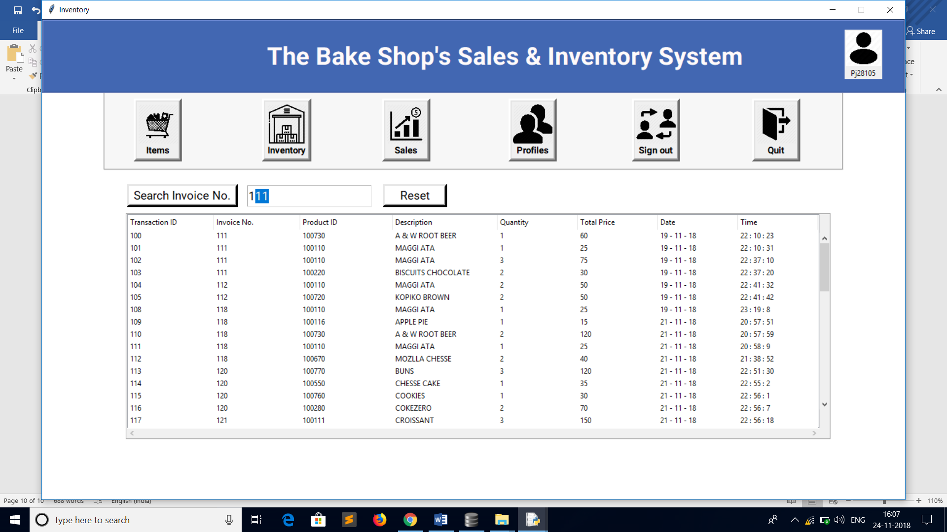

* Profiles-: To check Profiles currently in bakery’s database user can click profile button. All entry boxes will fill automatically if you select any row of the table. You can edit or remove accounts from the data base. You can also edit passwords of the user profiles.

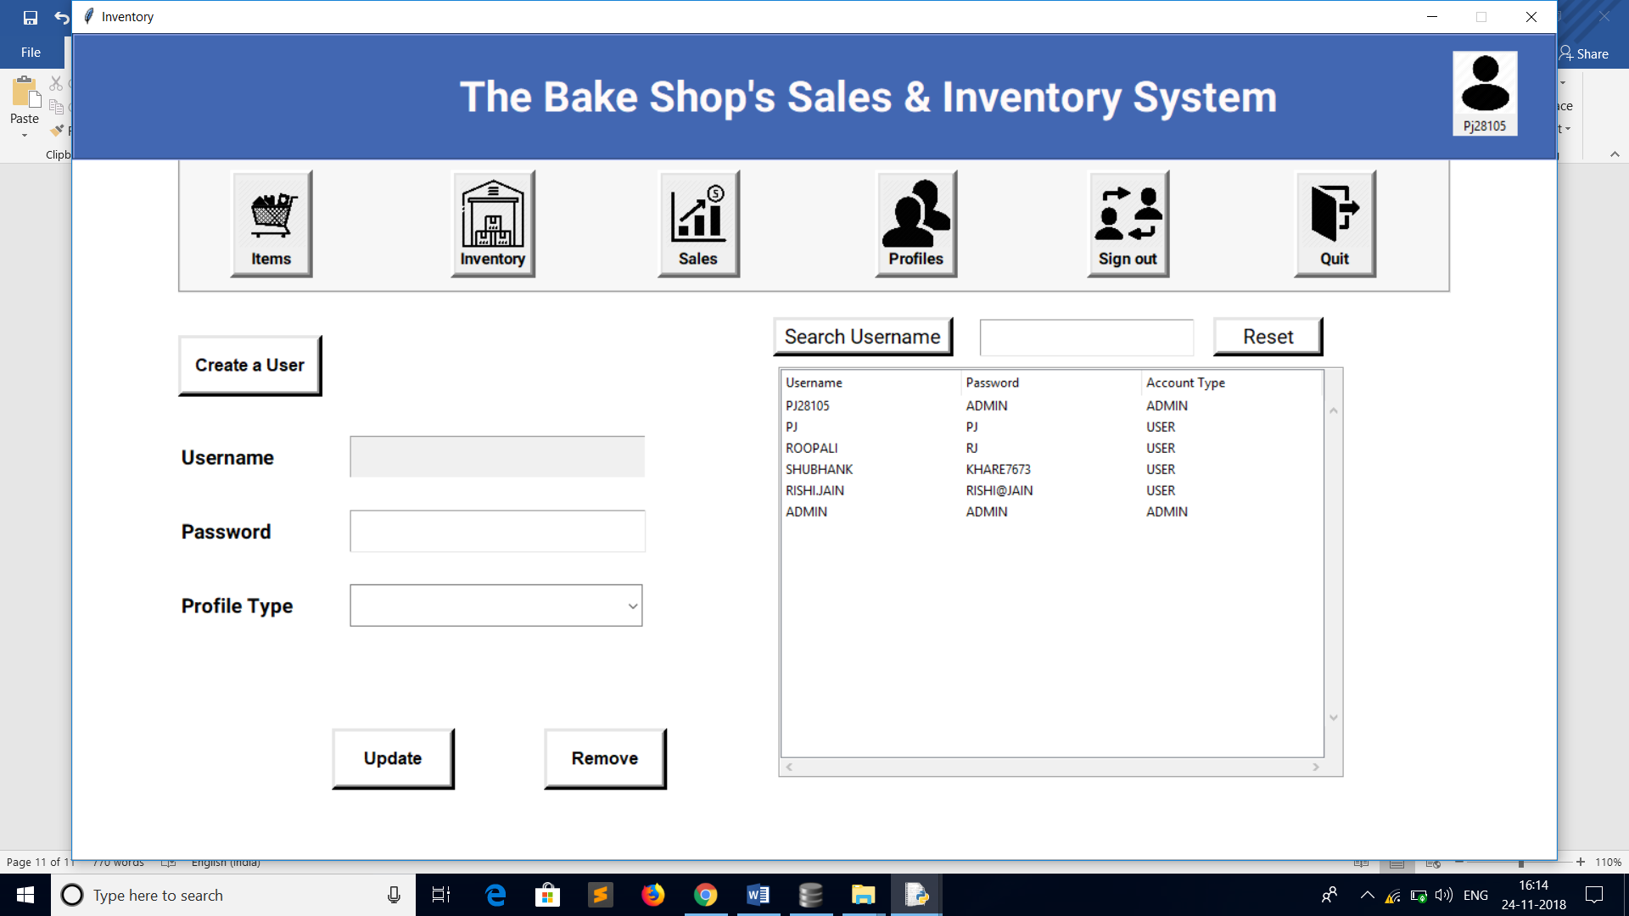

User can also create a new profile by clicking on create user button. A register user window will pop up. By default, it will create a User account. To make it Admin type you can edit its property through profile type combo box.

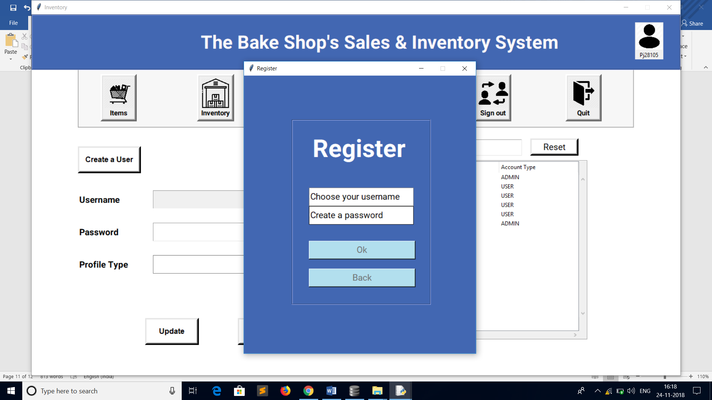

* Sign Out-: To sign out click sign out button. You will get back to Login window.

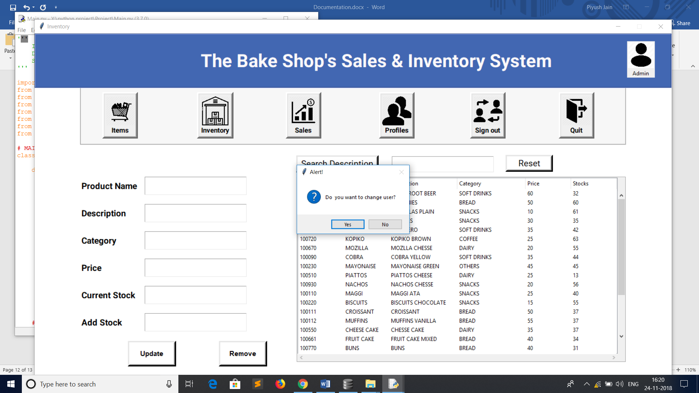

* Quit-: To quit Inventory user can press quit button to exit the Inventory or X button on the window.

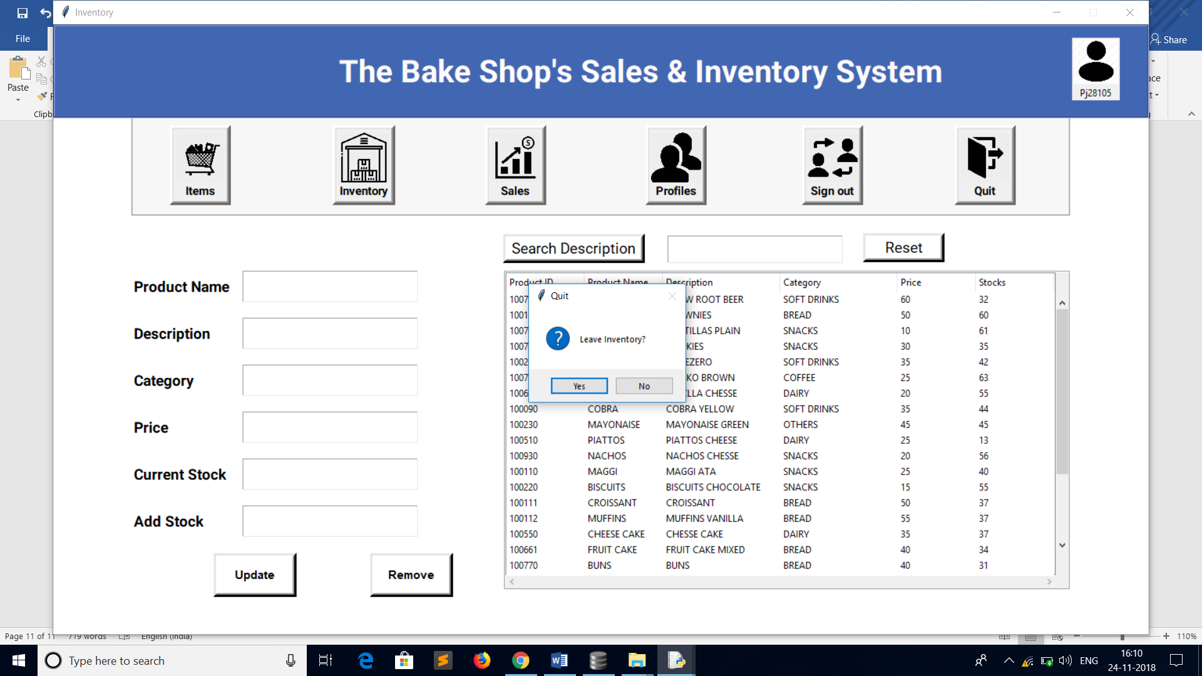

**USER ACCOUNT**

This a Limited access account. This account is for employees of the bakery. Through this account you can sell products, make transaction, can see current products in bakery etc.

* Invoice-: By clicking Invoice Button. You will enter to the transaction window. There is Invoice no. at top, this is bill no. by which you can fetch the bill details through Sales button in Admin type account.

After Invoice no. there is transaction table. It will get automatically filled when you enter a product for sale.

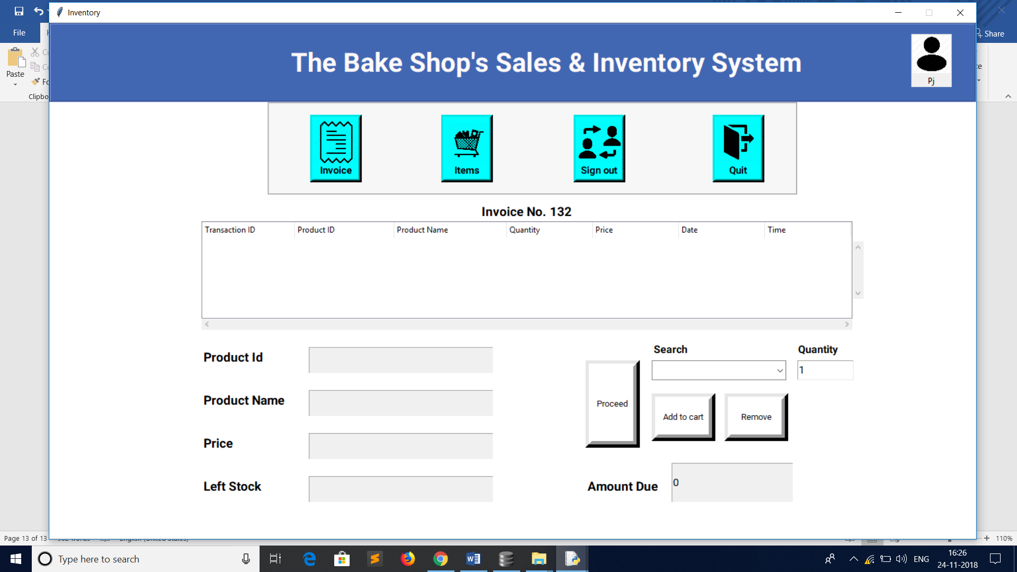

User can search Product by description or Product id in search box. This box will provide suggestions to the user. To make entry in Transaction table Press Add cart button. Automatically its product detail will get displayed. Here product details are not for edit it is a User type account.

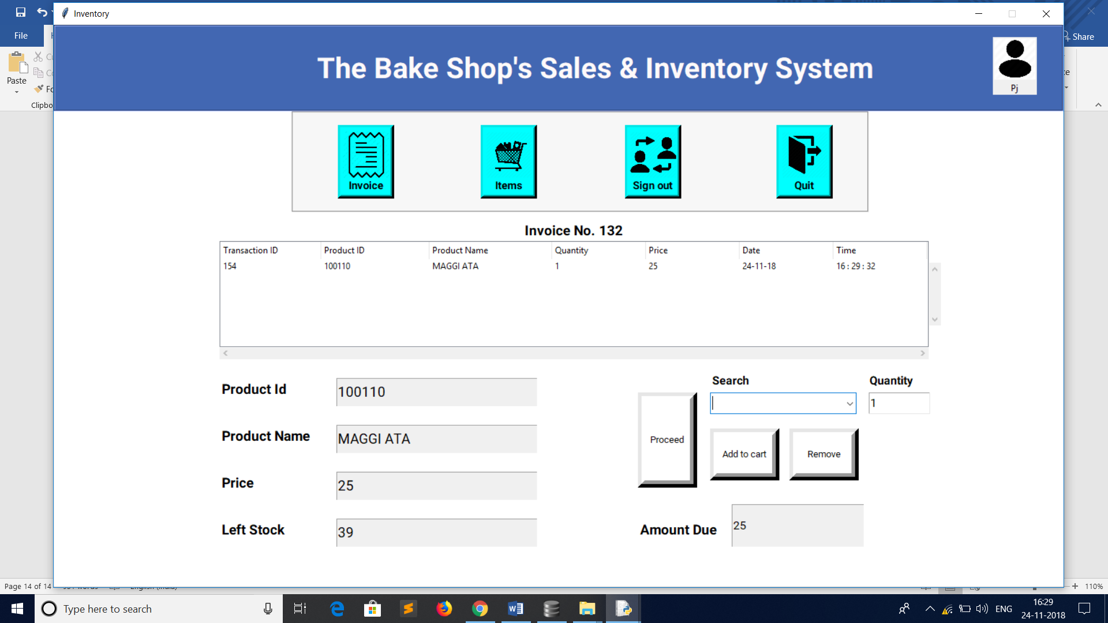

You can remove any record from current transaction by clicking remove button.

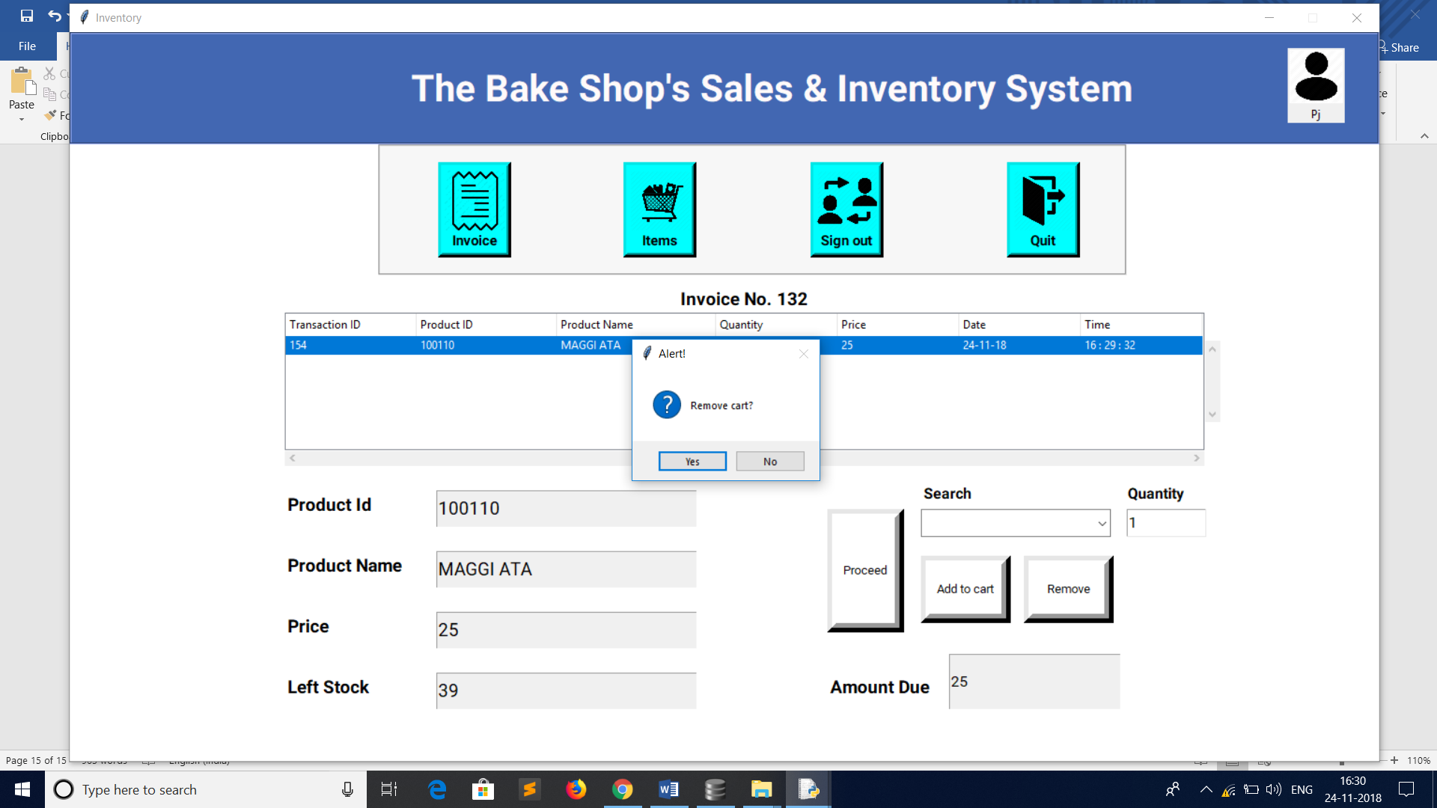

To make a Bill User can click proceed button.

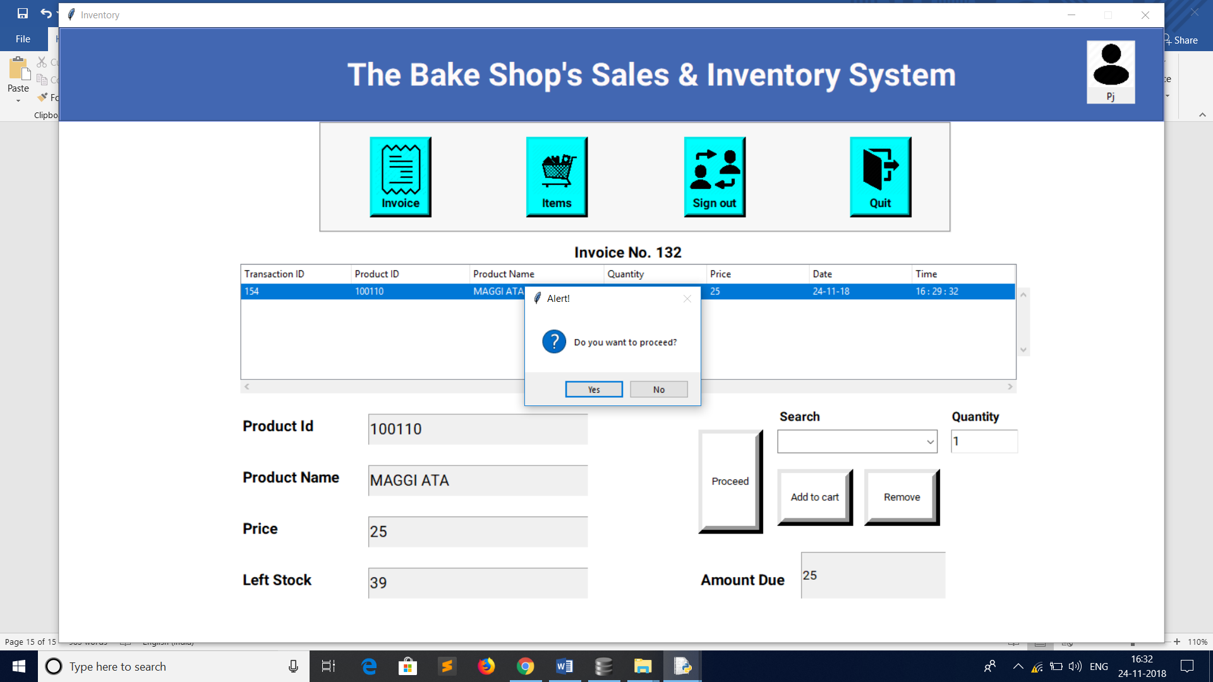

After proceed, it will prompt user to take a print out of this transaction.

* Items-: User can view Items in the bakery. The details are not for edit.

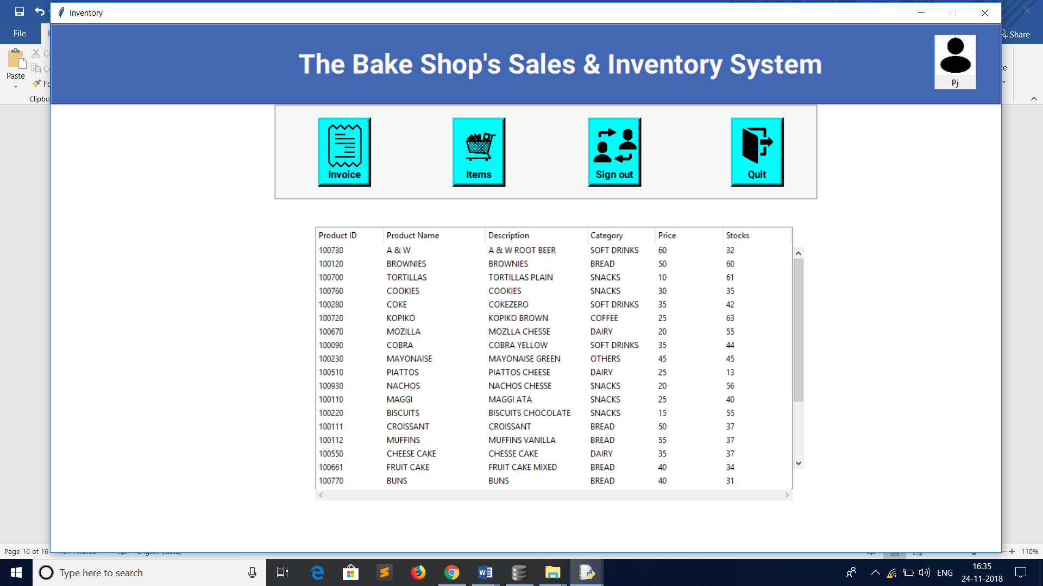

* Sign Out-: To sign out click sign out button. You will get back to Login window.

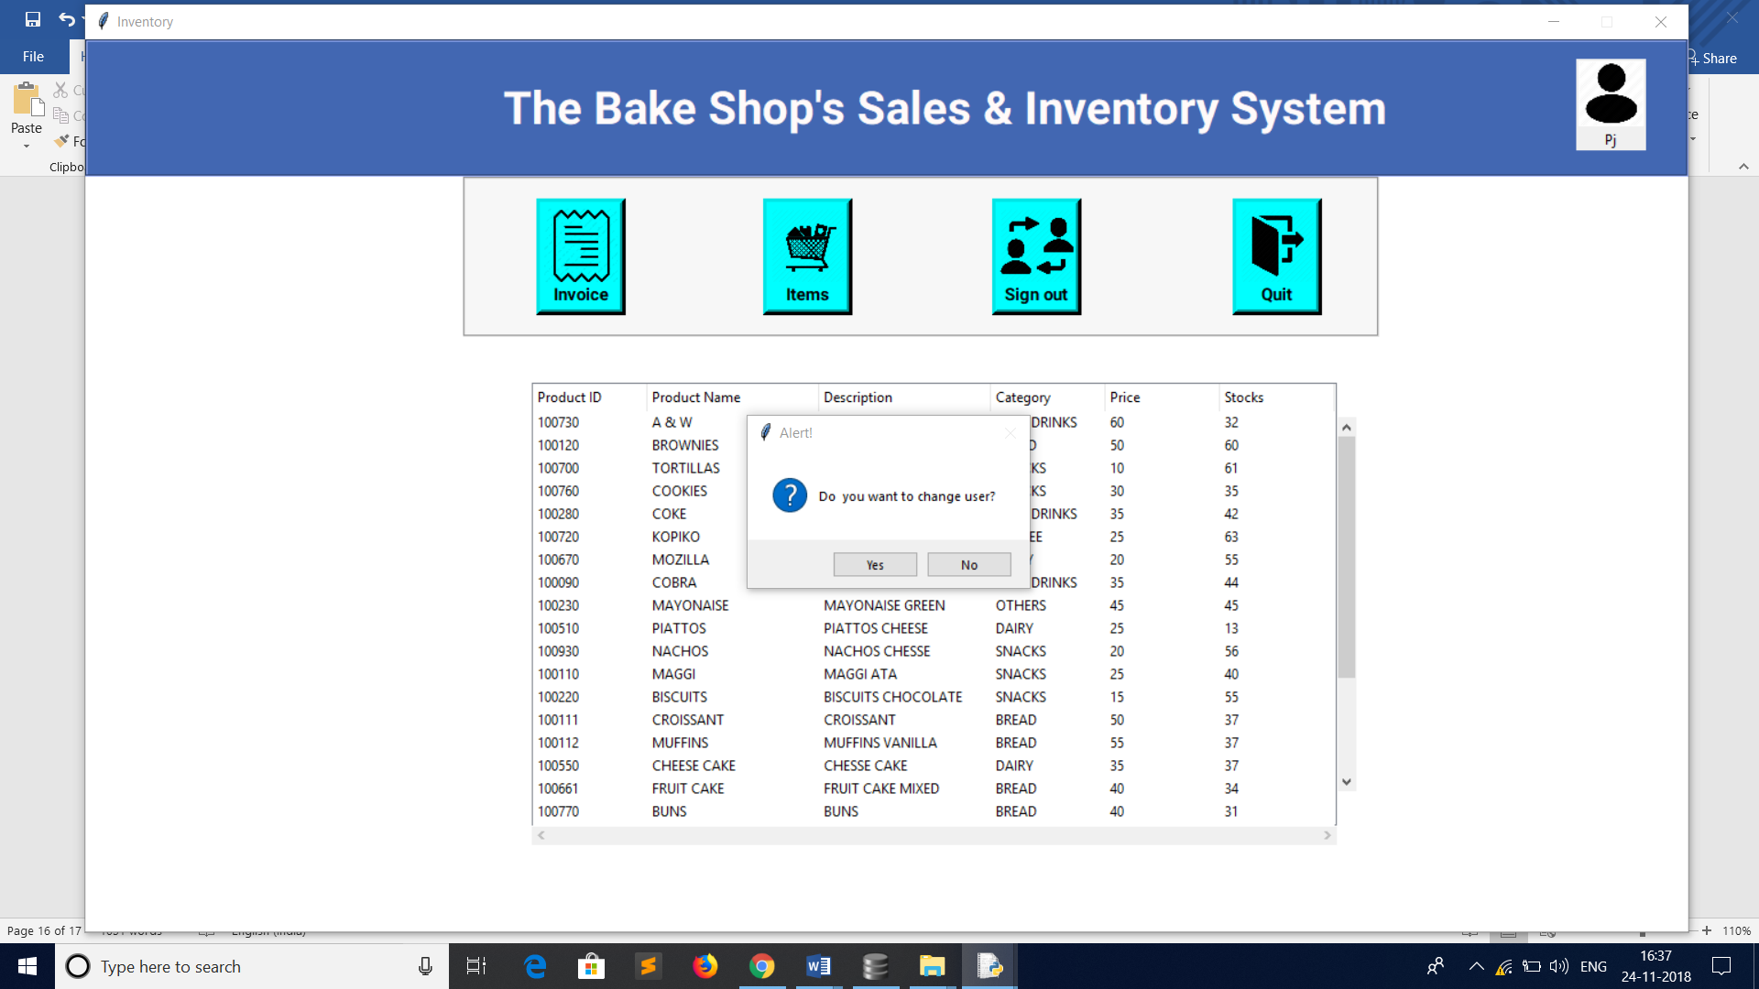

* Quit-: To quit Inventory user can press quit button to exit the Inventory or X button on the window.

